CAFÉ MANAGEMENT SYSTEM
A project submitted to
UKA TARSADIA UNIVERSITY
in partial fulfilment of the requirements for the degree of

Bachelor of Science in Information Technology
For
5 Years Integrated M.Sc.(IT)
For 5th Semester
By
Vishwa Chaturvedi
(201806100110127)

Guided by
Mrs. Preeti bhat
Assistant Professor



CERTIFICATE

External Examiner
Subject Teacher

AKNOWLEDGEMENT

WE WOULD LIKE TO EXPRESS OUR SPECIAL THANKS OF GRATITUDE TO OUR SOFTWARE ENGINEERING SIR “MR. BHAVIKSARANG” FOR THEIR ABLE GUIDANCE AND SUPPORT TO COMPLETING MY PROJECT.
WE WOULD LIKE TO EXTEND OUR GRATITUDE TO OUR HEAD OF DEPARTMENT SIR “MR. JITENDRA NASRIWALA” FOR PROVING US WITH ALL THE FACILITY THAT WAS REQUIRED.

Table of Content
Chapters | Particulars |  |  | Page no.
1 | Introduction
1 | 1.1 | Problem Definition
1 | 1.2 | Initial Requirement Document
1 | 1.3 | Project objective
 | 1.4 | Product Scope
2 | Overall Description
2 | 2.1 | Product Perspective/ Environment Description
2 |  | 2.1.1 | Hardware Interface/ Hardware Specification
2 |  | 2.1.2 | Software Interface/ Software Specification
3 | System Planning
3 | 3.1 | Software Engineering Model
4 | System Specific Requirements
4 | 4.1 | Functional Requirement
4 | 4.2 | Non-functional Requirement
5 | System Analysis
5 | 5.1 | Use case Diagram(s)
5 | 5.2 | Activity Diagrams
6 | System Design
6 | 6.1 | Database Design
6 | 6.1 | 6.1.1 | Database Schema
6 | 6.1 | 6.1.2 | Data Dictionary
7 | System Implementation
7 | 7.1 | Screenshots
8 | Testing
8 | 8.1 | Test Cases
9 | Future Enhancement
 | Conclusion
 | Bibliography

List of Figures
Figure no. | Figure Description | Page no.
5.1.1 | Use Case Diagram for Admin
5.1.2
5.1.3
5.2.1 | Activity Diagram for Manage Product
5.2.2
5.2.3
5.2.4
5.2.5

CHAPTER 1: INTRODUCTION
This document is intended for different type of readers such as café owner, the system designer, the system developer and the tester. By reading this document a reader can learn about what the project is implemented for and how it will present its basic idea. This document has a sequential overview of the whole project so if a reader reads the document from top to bottom; he / she will get a clear idea about the project.
  - Problem Definition:
Managing the café and all its orders and payments with special offers and discounts is so unorganized when you tend to do it manually. To make this task easy we propose a “CAFÉ MANAGEMENT SYSTEM”. This will eliminate all the traditional (manual) way of managing a café and provide an ease in managing all the tasks of café being done satisfyingly through the system where it facilitates customers to give order from home which saves time and provide ease to customers. It takes the work to digital platform where making and taking of order, payments and delivery will be at ease and quick.

1.2 Initial Requirement Document
Title of the project |  | Café management system
Stakeholders involved in capturing requirement |  | Myself and project guide
Techniques used for requirement capturing |  | Group discussion ,brainstorming
Name of the person along with designation |  | Vishwa chaturvedi(student)  preeti bhatt(project guide)
Date |  | 31 July , 2020
Users of the system |  | Admin, chef, customer, delivery boy
Version |  | 1.0
Consolidated list of initial requirements:
Requirement #1 | A system is to be implemented which can manage online orders (browser) as well as run on café computer.
Requirement #2 | The system shall be able to access through username and password for the users.
Requirement #3 | The user shall be able to manage their profile like: change password and manage personal information.
Requirement #4 | There are four users in this system namely:  a) Administrator  b) chef  c) customers  d) delivery boy
Requirement #5 | The customer shall be able to see the item details like pricing offers on the particular item (if applied)
Requirement #6 | The customer shall be able to place online orders and make advance booking.
Requirement #7 | The system shall be able to accept online orders made by customers.
Requirement #8 | The customer shall be able to view the orders they placed.
Requirement #9 | The café staff shall be able to take feedback and reviews from their customers through system.
Requirement #10 | The admin shall be able to view customer’s feedback.
Requirement #11 | The system shall be able to display the orders to the chef in the kitchen.
Requirement #12 | The system shall be providing some special offers to the customer on festive and other occasion.
Requirement #13 | The system shall be able to view the order details to the admin.
Requirement #14 | The system shall be able to display delivery status to admin as well as customer.
Requirement #15 | The system shall be able to notify for the advance booking made by customers.
Requirement #16 | The system should be able to generate reports like :  - Employee report  - Item(order) report  - Billing report  - Delivery report  - Customer feedback report

Abbreviations:
- CMS- café management system

1.3 PROJECT OBJECTIVE:
This CMS helps the café’s manager to manage the café more effectively and efficiently by computerizing the orders, billing and transactions. Here it takes the café managing task on a digital platform.
This system will also help the manager to make appropriate business decisions for the café as the transactions and other information of staff will be stored in the system. Here the customers will be giving orders and are able to make advance booking of the café sitting at their homes. Moreover, there will be easy calculation of daily expenditure and profit. The whole system is designed for a general computerize digital café. So that any café owner can get it and start automated process of his own café.

1.4 PRODUCT SCOPE:
A café management system is used in building up the networking to help the service providers gain customer and introduce a new revenue generating services. This CMS can be used by all the general public. This system is primarily structured to create a great customer base business which provides an ease in maintaining customer order management, managing event held at the café, billing and rating. CMS typically includes business-to-consumer (B2C) service. This system will help to manage and run the café business systematically.
The primary CMS areas are as follows:
- Product ( food items) management
- Customer management
- Online ordering management
- Advance booking management
CHAPTER 2: OVERALL DESCRIPTION:

2.1 PRODUCT PERSPECTIVE
The café Management shall be developed using client/server architecture and compatible with Microsoft Windows Operating System .The front-end of the System will developed using visual studio 2010 and the back-end will developed using Ms SQL Server 2008.
Back-end Database

Front-end client application (maintain stock, sales calculation)

2.1.1 HARDWARE INTERFACES
- Screen resolution of at least 640 * 480 or above.
b) Computer system will be in the networked environment as it is a multi-user system.

2.1.2 SOFTWARE INTERFACES
- MS-Windows Operating System.
- Microsoft Visual Studio 2010 for designing front-end.
- Ms SQL server 2008 for back-end.

CHAPTER 3: SYSTEM PLANNING
3.1 SOFTWARE ENGINEERING MODEL
Waterfall Model
We have followed this model step is…
- Requirement Analysis
- Design
- ** Analysis **
- Implementation
- Unit Testing
- Integration And Testing
- Deployment And Maintenance
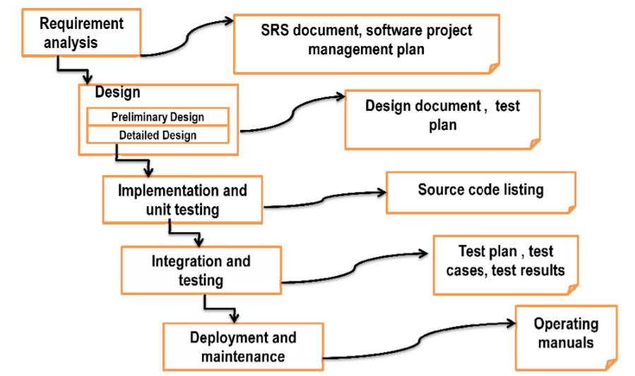
- The waterfall model begins with the system. It gathers requirements from the customer. At the end SRS and software project plan are produced. The SRS acts as a contract between the customer and the developer.
- In the design phase, the SRS is transformed into design which is suitable for implementation in a programming language.
- First preliminary design is made then detailed design is m initial test plan are produced at the end of this phase
- During the implementation phase.
- In unit testing small modules are tested in isolation and the overhead code is written for handling communication amongst these modules.
- After implementation and unit testing, the modules are integrated to form a complete system. Integration and testing are carried out to verify the functionality of the system.
- After proper testing the software is, test phase and test results are outputs in this phase.

CHAPTER 4: SYSTEM SPECIFICATION REQUIREMENTS
4.1 Functional Requirements:
- Module 1: Registration and Login
RN | Description | Comments
FR1 | The USER shall register themselves in order to create a new account for using the system. The system shall provide an interface where users have to provide the following details to get registered :  Name (username), Email, Password, Address, DOB, Gender, Contact number. | Registration form
FR2 | The registered users can manage their profile and update the following details like: Contact number, email id, address, change password, profile picture, DOB | Manage profile
FR3 | Separate login is maintained for each user. Administrator, chef, delivery boy and customer will be authenticated with their username and password to login into the system. | Login form
FR4 | After logging in the members should be directed to home screen of the system. | Home page

- Module 2: Manage Customer details
RN | Description | Comments
FR1 | Customers shall enter their respective username and password for login. | Login form
FR2 | System shall authenticate user login to the system | User profile
FR3 | Customer may be able to update their detail whenever they require. | Manage profile
FR4 | The system will allow admin to “view” customer details like name, dob, address, etc. which are added at the time of registration.
FR5 | Viewing Order history of particular customer.

- Module 3: Manage Staff details
RN | Description | Comments
FR1 | Staff members shall enter their respective username and password for login. | Login form
FR2 | The system shall be able to allow staff members to change their password and make update in their details like address, contact number etc. | User profile
FR3 | The admin shall be able to view number of employees who is working in café and all their details which they entered during registration. As well as admin would be able to know who joined and who left.

- Module 4: Managing café items and related information:
RN | Description | Comments
FR1 | Administrator and chef shall be able to perform following operation for item details:  - Add new item details  - Update item details  - Edit pricing  - New category  - Description of item, price, picture (optional)  - Delete if necessary  - View/ search product details | Add item
FR2 | Only admin will Manage special offers or discounts on items during festivals.
FR3 | The system will allow the customers to search items by categories to place order. | Search item

- Module 5: Manage order
RN | Description | Comments
FR1 | The customer can create temporary list of items by adding them to cart and place order. Customer shall be able to add or remove item from cart. | Add to cart & place order
FR2 | A unique order id is generated for each order. Order id, item id, description of item and amount must be included while recording order for each customer.
FR3 | Allocating orders to chef as well as delivery boys.
FR4 | Status of order(preparing/made/delivered)  The system will allow the staff members like chef, and delivery boy to update status like:  - Chef-(order status) [made/pending]  - Delivery boy ( order delivery status) | Update order status

- Module6 : generate bill
RN | Description | Comments
FR1 | Fetch the ordered items from list, enter quantity ordered, apply tax involved and give discounts if any available. | Create bill
FR3 | Customer selects either of the following payment modes:  - Net banking  - COD(Paying at the time of delivery of at the chosen address)  “No other payment gateways allowed” | Payment
FR3 | Final bill is generated with following details: Customer id, customer name, item id, item detail, quantity of items and the total amount payable. And being displayed to the customers | View final bill

- Module 7: Manage Advance Booking
RN | Description | Comments
FR1 | The customer shall also be able to make booking for “event” in advance  Which include: day, date, menu for the event
FR2 | Admin will be having option for accepting or rejecting the booking as per the availability or the situation | permission
FR3 | The system shall be able to record the customer’s details that made advance booking.
FR4 | No cancelation allowed for the booking.
FR5 | The system shall be able to notify for the advance booking made by customers.

- Module 8: Manage Feedback
RN | Description | Comments
FR1 | Customer will be able to give feedback about the product or the service provided to them. Administration shall be able to view the feedback whenever received. | give review
FR2 | Feedback form will be having the customer name and id so that it helps the café members to do some changes accordingly as per the feedback. | Report

- Module 9: Report
RN | Description | Comments
FR1 | The system shall be generating reports to keep record.
FR2 | Bill report/income report  Order report  Booking report  Customer feedback report  Delivery report | Generate report

4.2 Non-Functional Requirements:
RN | Description | Comments
NFR1 | A basic user-friendly interface is made so that each every user can easily understand and operate the system and its functions. | User-friendly
NFR2 | The application will be easily portable on any windows-based system that has SQL Server installed. | Portability
NFR3 | User will have to enter correct username and password to access the system. The password will be stored in database using MD5 algorithm.
NFR4 | The system should be designed to remove all the possible failures.

CHAPTER 5: SYSTEM ANALYSIS
5.1 USE CASE
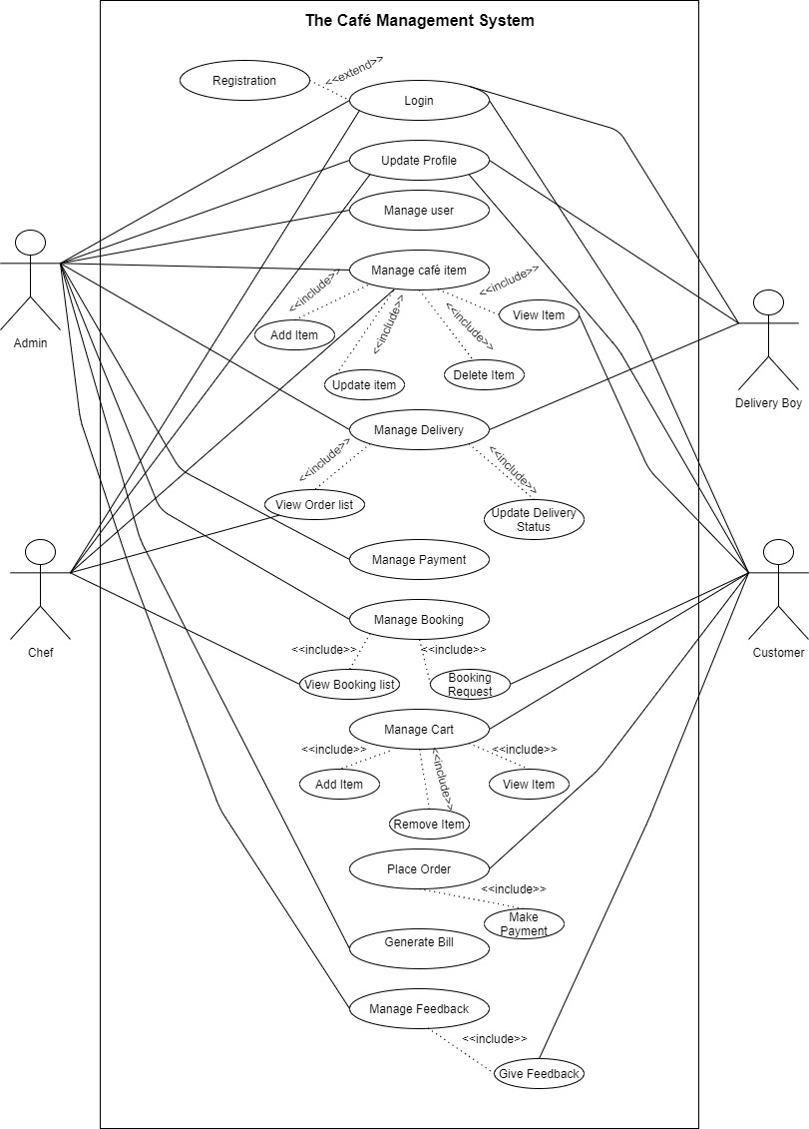

5.2 ACTIVITY DIAGRAM
REGISTRATION:
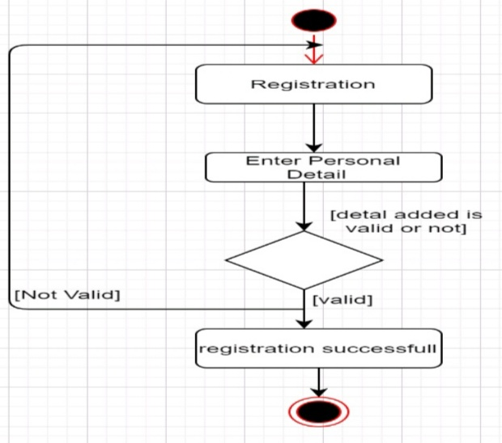

Login
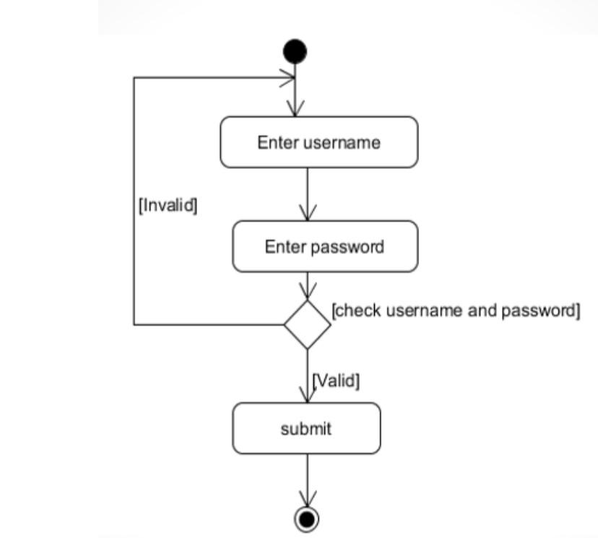

Change password
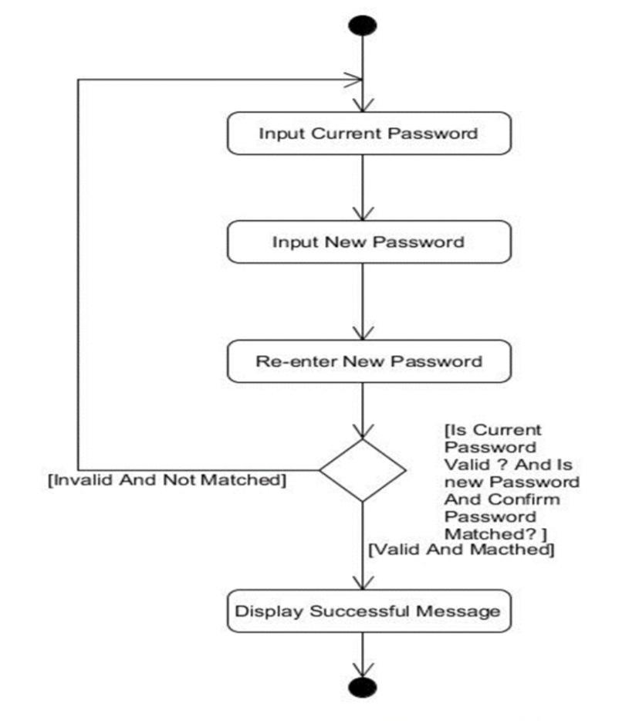

Manage user detail
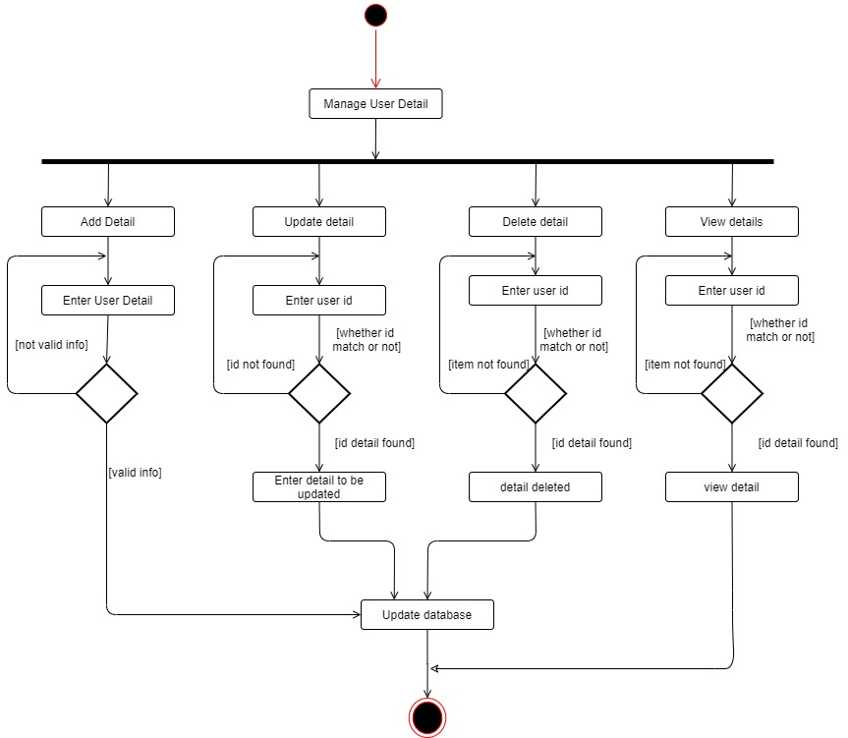

Manage item and related information
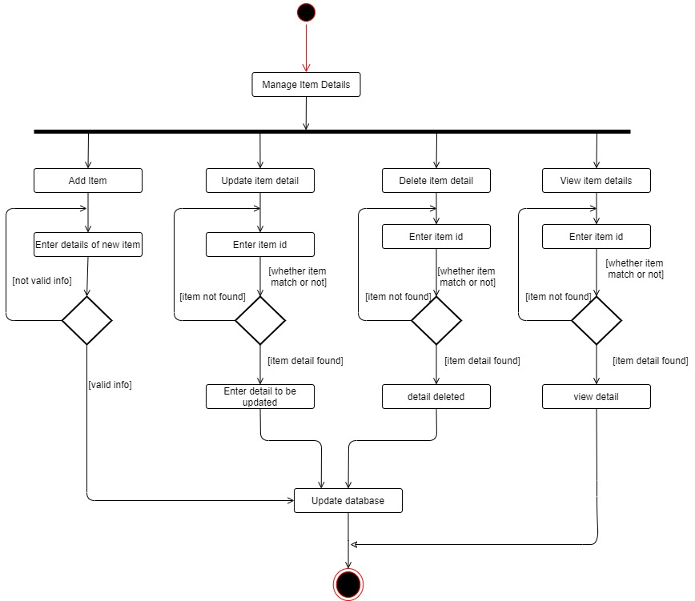

Bill generation:
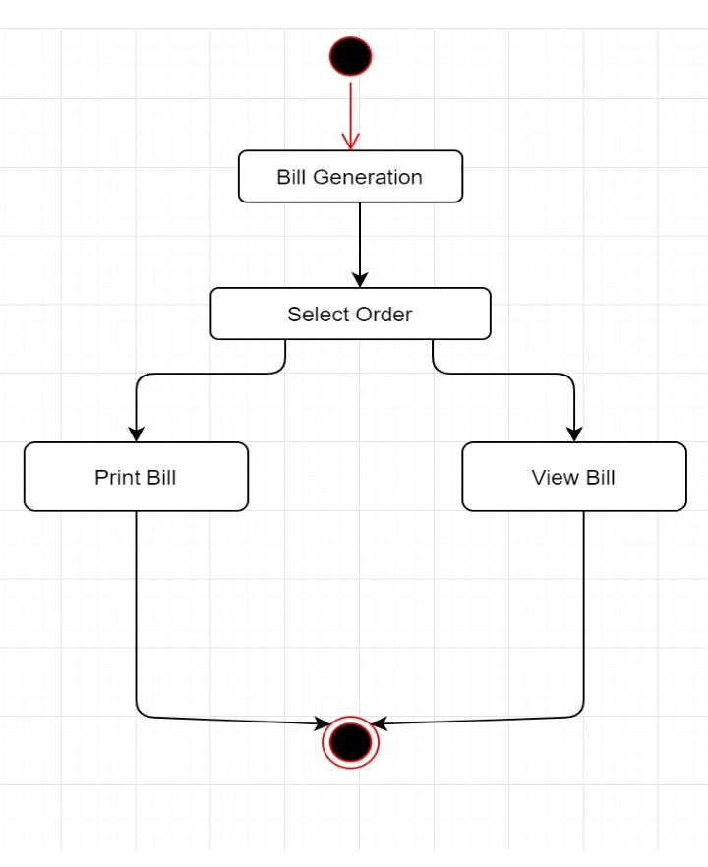

Place order
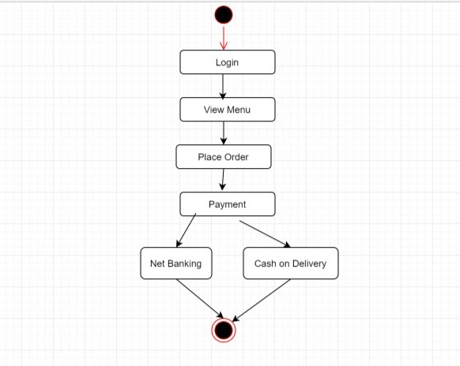

Manage booking:
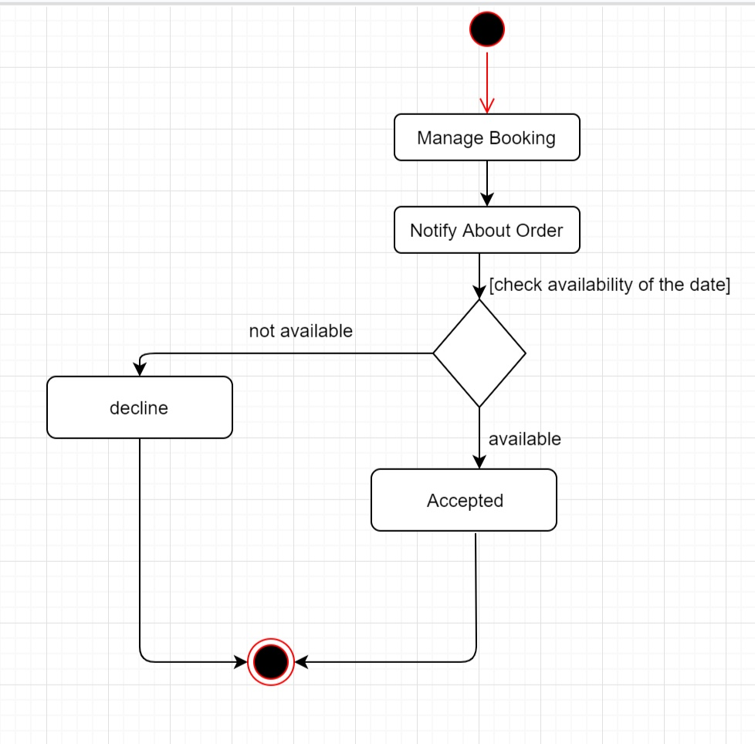

Feedback:
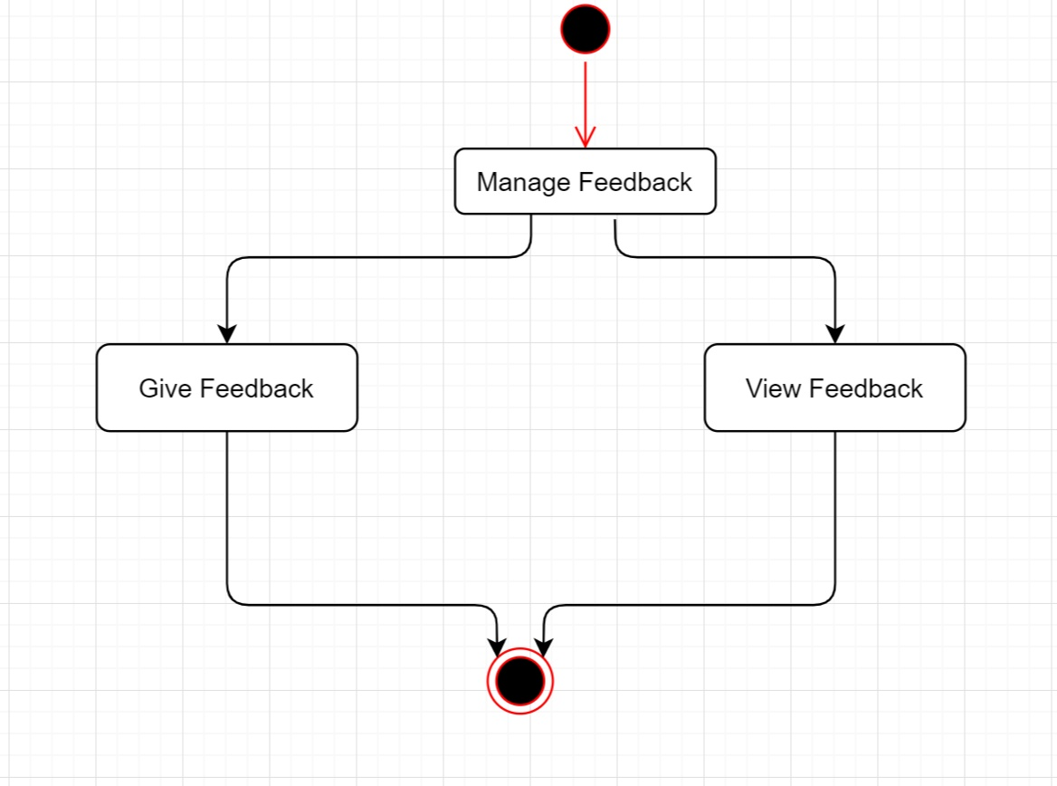

System Design
Database Design

Symbol of key=Primary key
Symbol of key with star=primary key with auto_increment

6.1.1 Database schema
TBL_Customer(Customer_id[PK],username,Password,Email,address,Gender,contactno,DOB)
FD:Customer_id-> username, Password, Email, address, Gender, contactno, DOB

TBL_Delivery_boy(db_id[PK],usernamePassword,Email,Gender,contactno,age,DOB)
FD:db_id-> username, Password, Email, Gender, contactno, age, DOB

TBL_Chef(C_id[PK],username,Password,Email,Gender,contactno,age,DOB)
FD:C_id-> username, Password, Email, Gender, contactno, age, DOB

TBL_Item(Item_id[PK], Item_name,cost,Item_Description,Customer_id[FD])
FD:Item_id-> Item_name ,cost, Item_Description

TBL_order(Order_id[PK], Customer_Address, Customer_id[FD], Delivery boy_id*[FD],Amount)
FD:Item_id-> Customer_Address, Amount

TBL_Payment(Customer_id[FK],Order_id[FK],Payment Date, Amount, Payment option)
FD: Customer_id-> Payment Date, Amount, Payment option

6.1.2 Data Dictionary:
TBL_Customer
Filed | Type | Size | Key | Description
Customer_id* | Int | - | Primary  auto_increment | With Payment table
Password | Varchar | 20 |  | MD5 encryption
Email | Varchar | 50 | Unique
Address | Varchar | 255
Gender | Varchar | 2
Phone | BigInt

TBL_Delivery boy
Filed | Type | Key | Description
db_id* | Int | Primary  auto_increment
Password | Varchar(20) |  | MD5 encryption
Email | Varchar(50) | Unique
Gender | Varchar(2)
Phone | BigInt
Age | Int

TBl_Chef
Filed | Type | Key | Description
C_id* | Int | Primary  auto_increment
Password | Varchar(20) |  | MD5 encryption
Email | Varchar(50) | Unique
Gender | Varchar(2)
Phone | BigInt
Age | Int

TBL_Items
Filed | Type | Size | Key | Description
Item_id* | Int | - | Primary  Auto_increment
Item_name | Varchar | 50
Cost | Int | -
Item_Description | Varchar | 255
Customer_id* | Int | - | Foreign key  Auto_increment

TBL_Order detail
Filed | Type | Key | Description
Order_id * | Int | Primary  auto_increment
Customer_Address | Varchar(255)
Customer_id* | Int | Foreign key
Delivery boy_id* | Int | Foreign key  auto_increment
Amount | Int

TBL_Payment
Filed | Type | Size | Key | Description
Customer_id* | Int | - | Foreign | With Class Login table
Order_id* | Int | - | Foreign | With Payment table
Payment Date | Date | -
Amount | Int | - | Foreign | With orderTable
Payment option | Varchar | 50

System Implementation
Screenshots

Admin Login
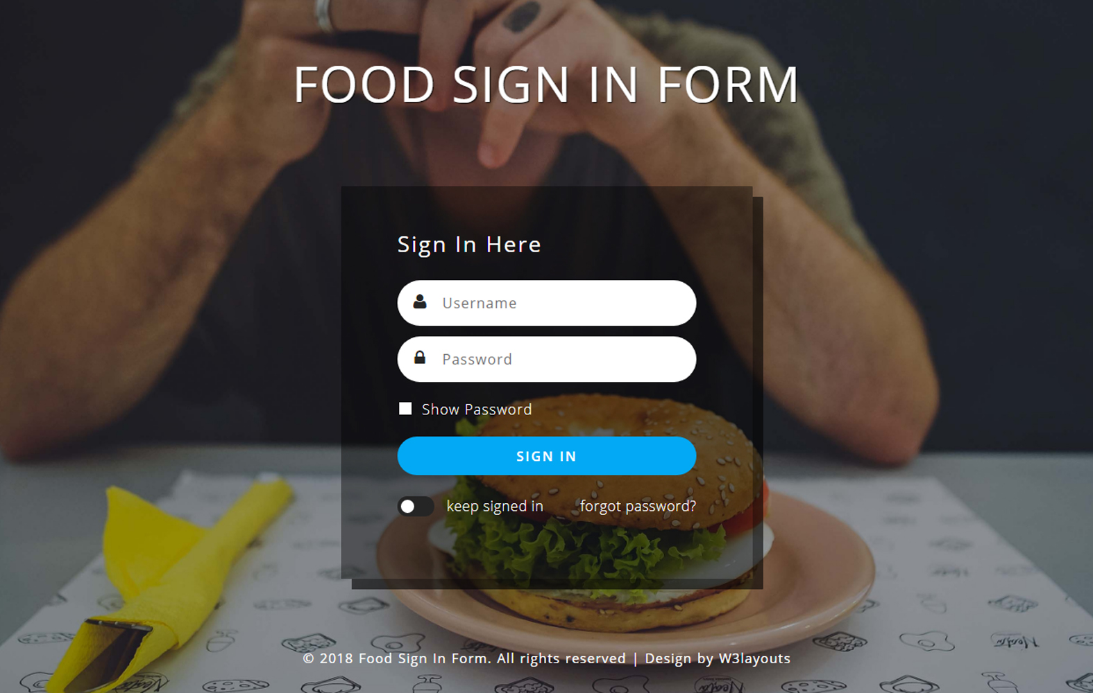
- Password protection encryption

Menu
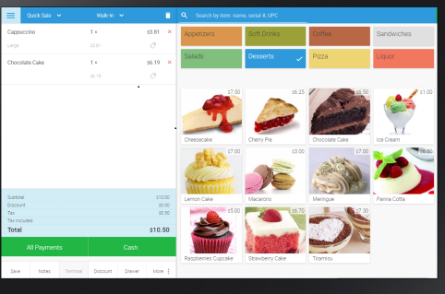

Feedback form
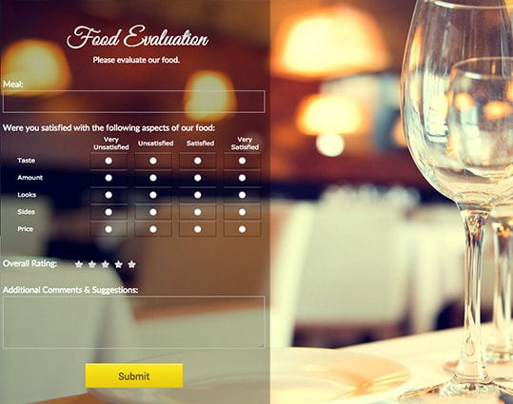

Conclusion
  - This system provides an easy way for the operator to interact with database and manipulate the data in the database.
  - The operator can add, delete, update and search records in the database with ease.
  - This system will lead to paperless society and manage all the data.
  - It provide easy, accurate, unambiguous and faster data access.
  - This project is therefore, designed in order to minimize the day to day problem.

BIPLIOGRAPHY

BOOK REFERRED: • Book Name: object oriented software engineering •
Author Name: Yogesh Singh, Ruchika Malhotra

Site Reffered :- www.w3school.com  

